User Registration Request Form Process
Click here to watch

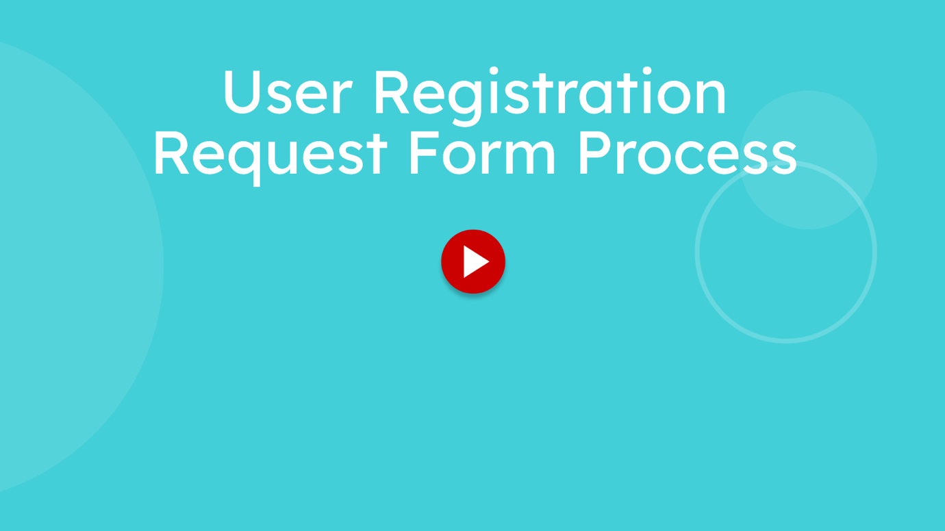
This training covers the complete process of submitting a user registration request form within the Honeywell system

Go to dss-requestform.honeywell.com

1. Open Request Form Version
You will be landed on the homepage.
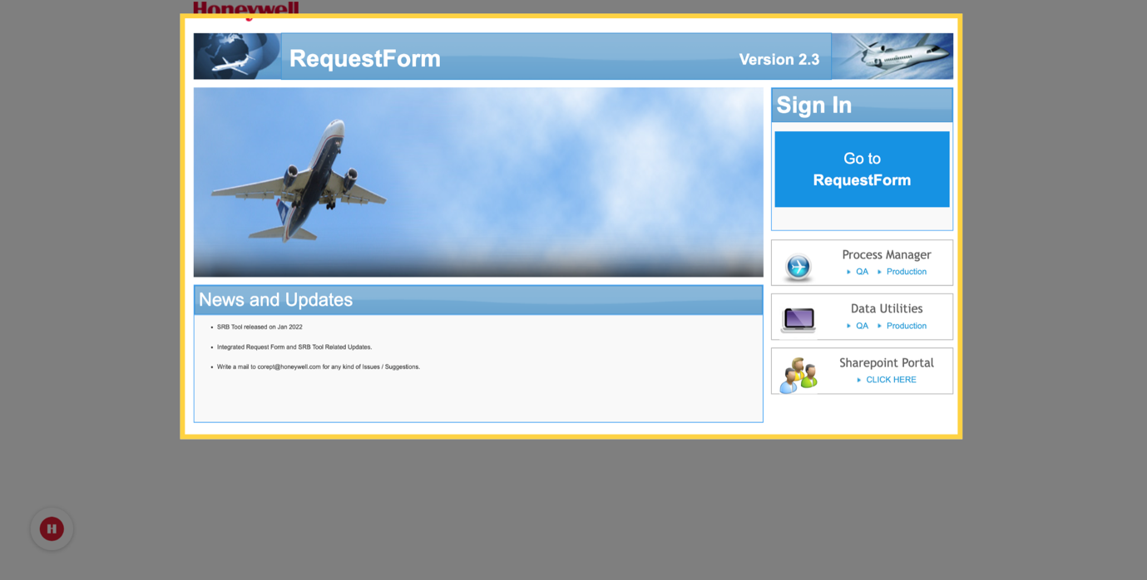

2. Navigate to Request Form
Click on the Go to Request Form button from the dashboard.
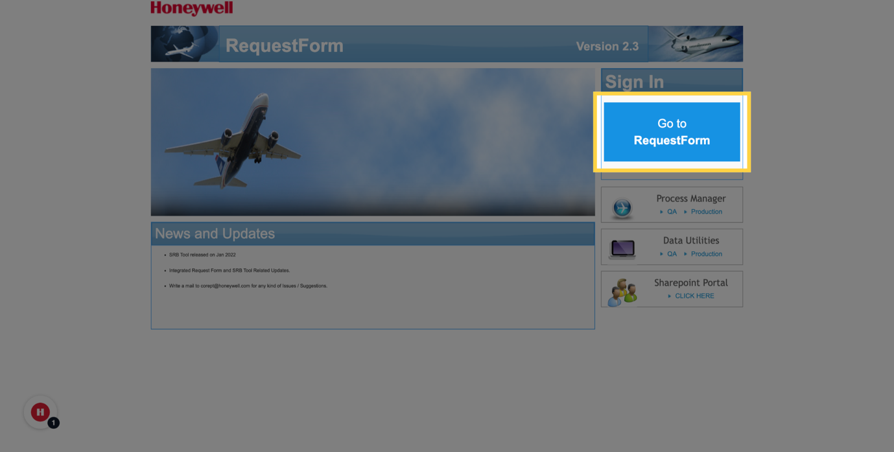

3. Access Authentication Link
You will be asked to enter the EID.
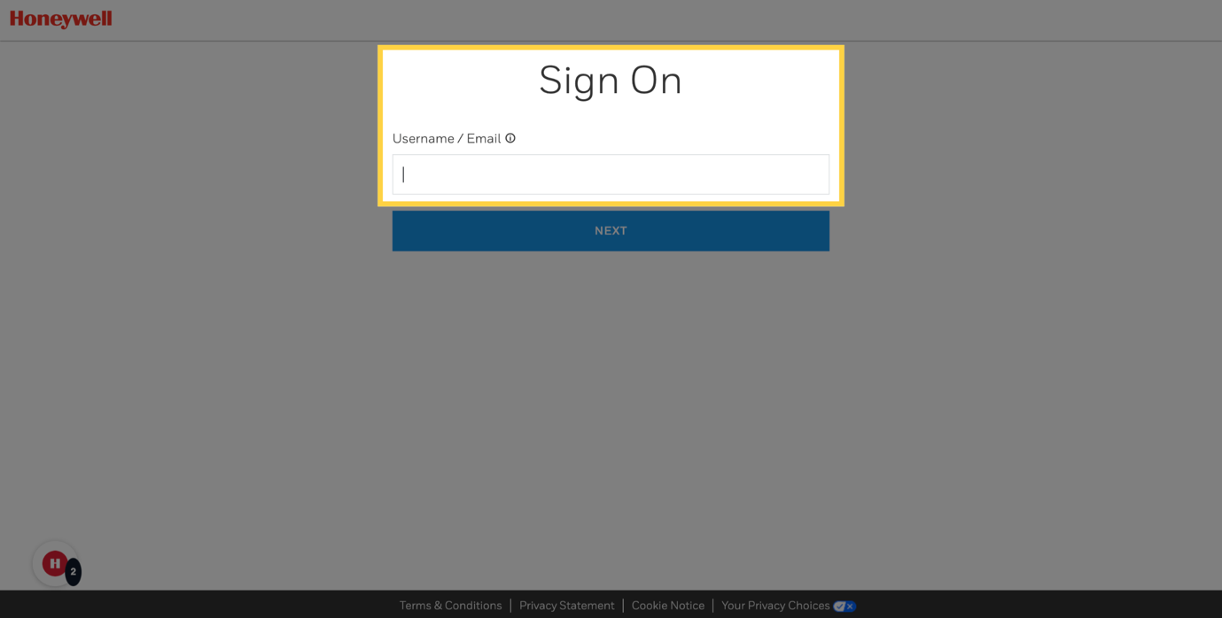

4. Proceed to Next Step
After entering EID, click ‘NEXT’ to proceed further.
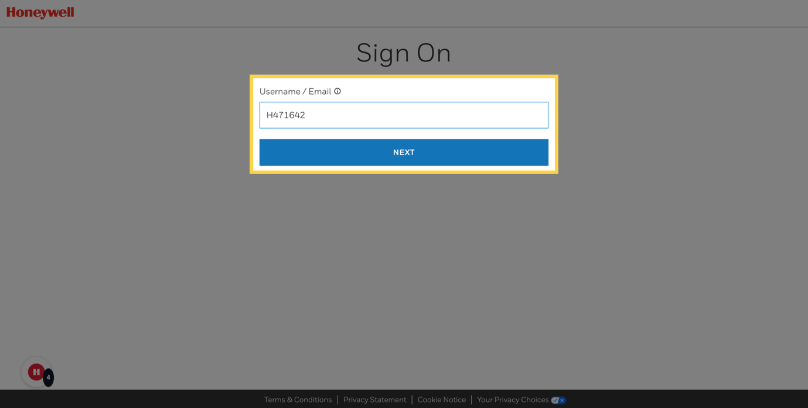

5. Open User Registration Section
For new users first login, will be redirected to the User Registration page.
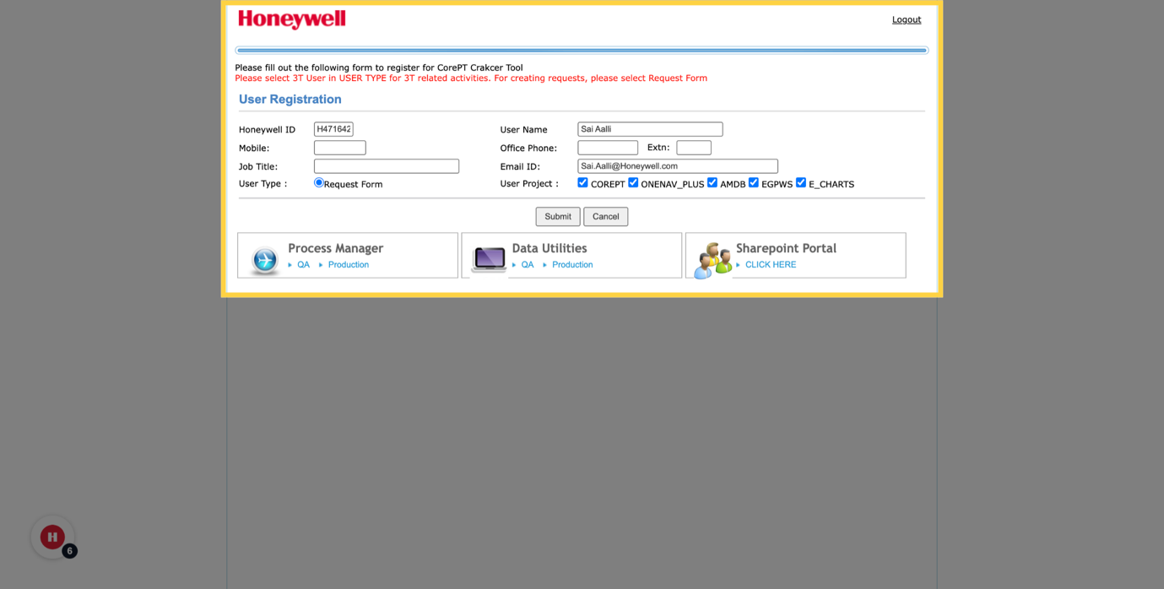

6. Open User Registration Section
By default, all projects are selected. 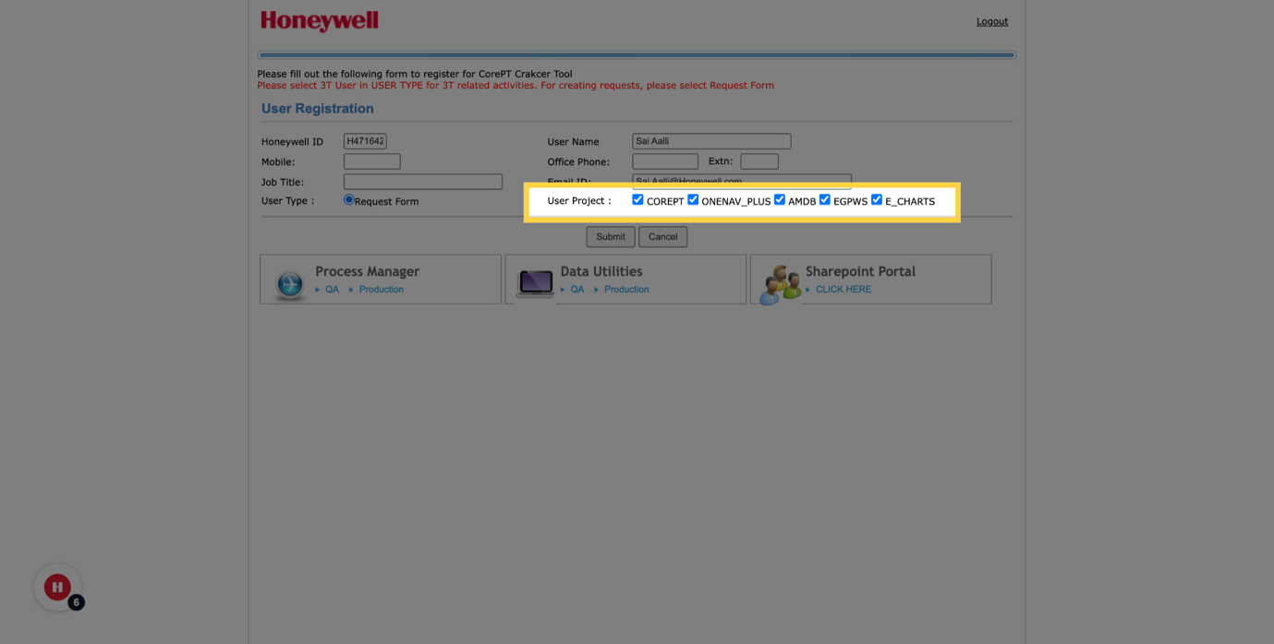

7. Submit Registration Details
To exclude specific projects, deselect them.
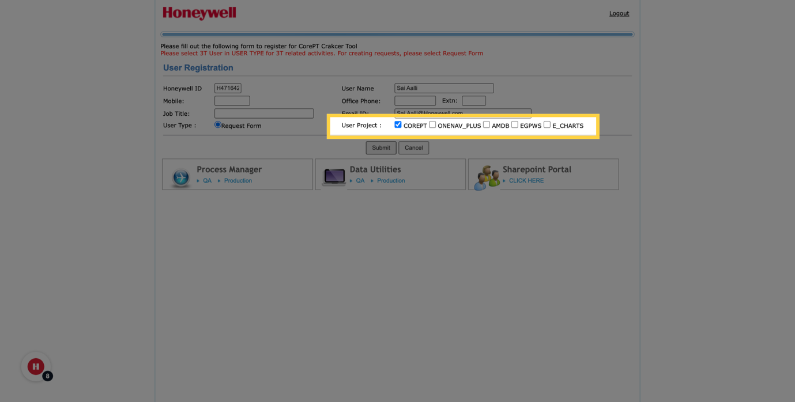

8. Submit Registration Details
And then click submit.
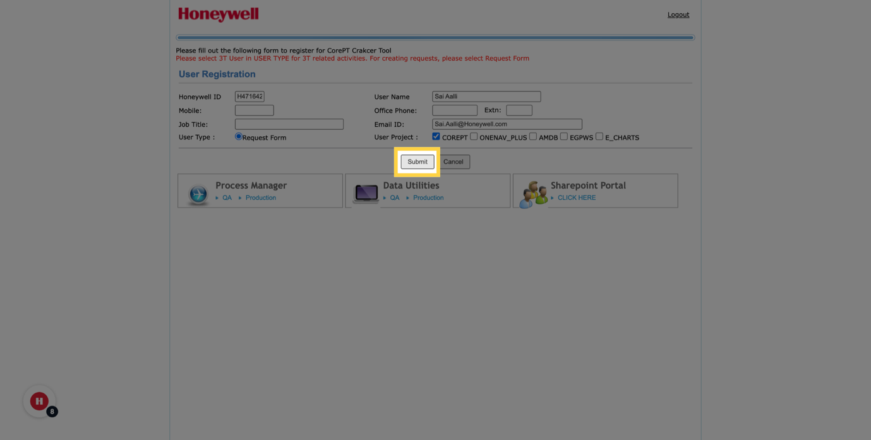

9. Navigate to Request Dashboard
You will then be taken to a page showing all the requests created under this project.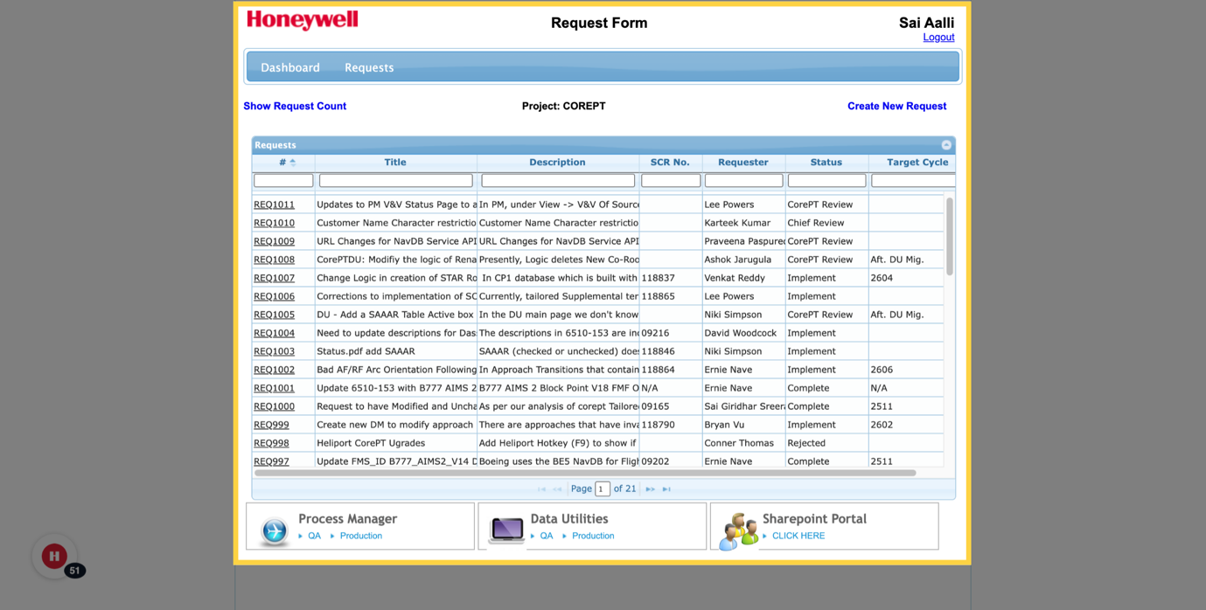

10. Access Request Dashboard
If you are looking for a specific request, you can use the search bar option on the top.

